- Sometimes we get into dilemmma, which mchine learning model to be used for my project, for example. To classify the iris, I can use many machine learning models, like SVM, Random forest etc etc. To answer this question we use Cross Validation.
- 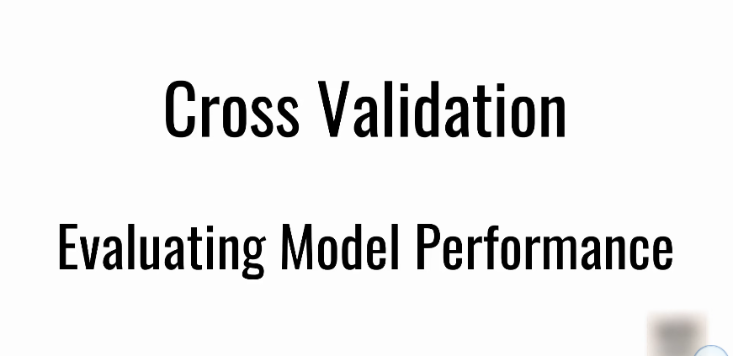
- 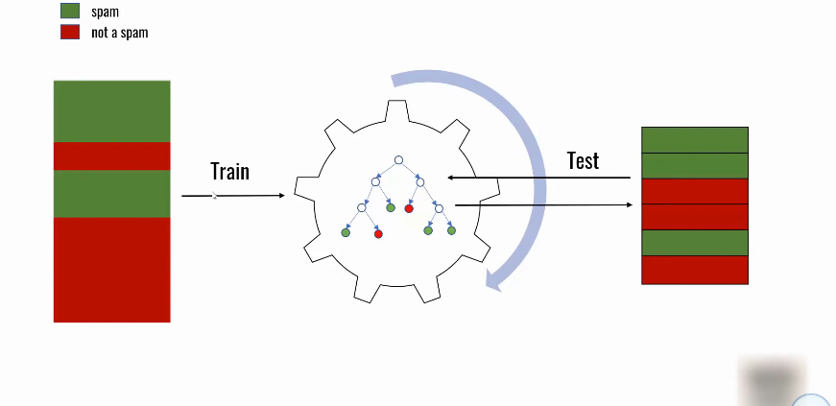
- 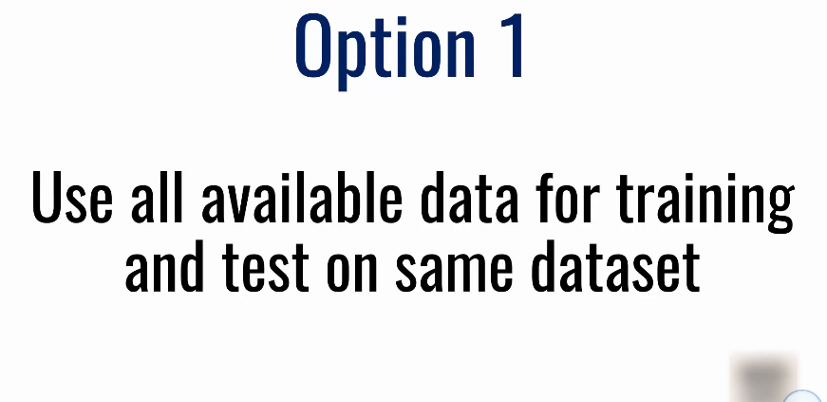
- 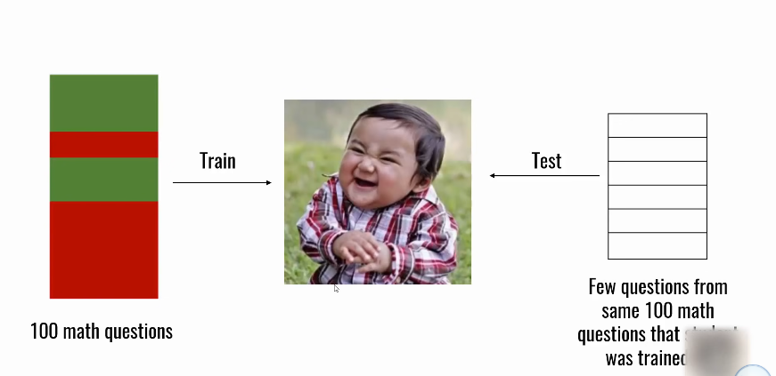
- 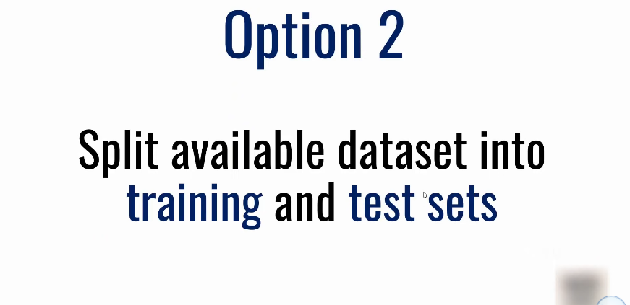
- 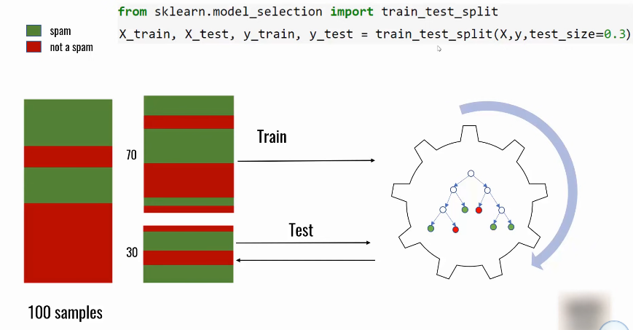
- 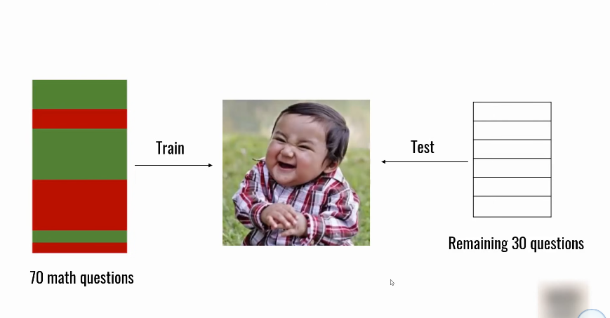
- Failure 2 Even here there is probelm , so what we give the model to train is algebra and asking calculus topics, this will not work properly at this time.
- 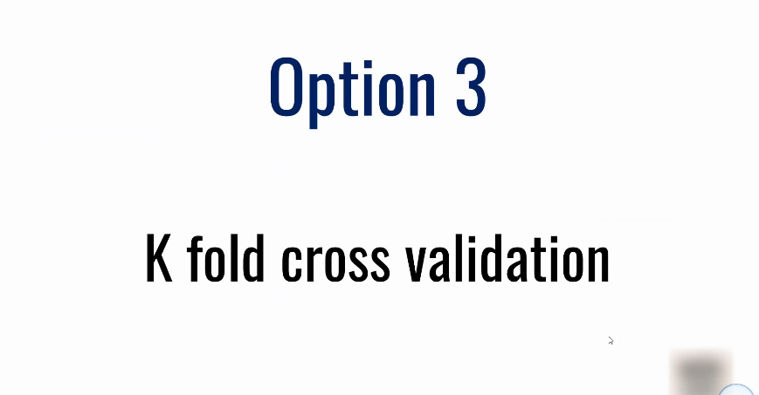
- 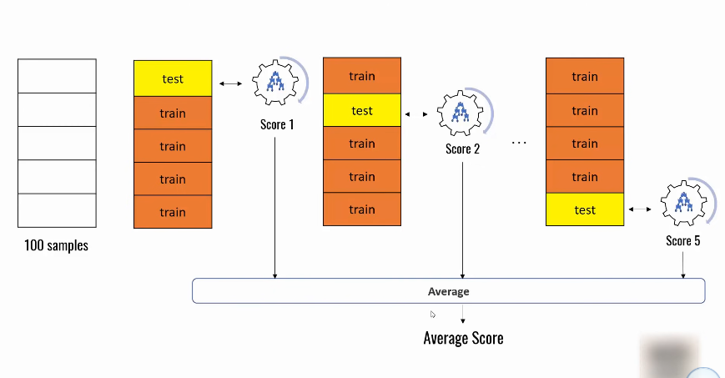
- In this we are giving the variety of samples folds to the model to learn. 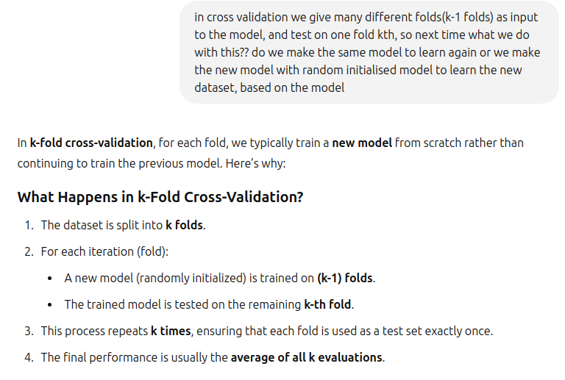
- 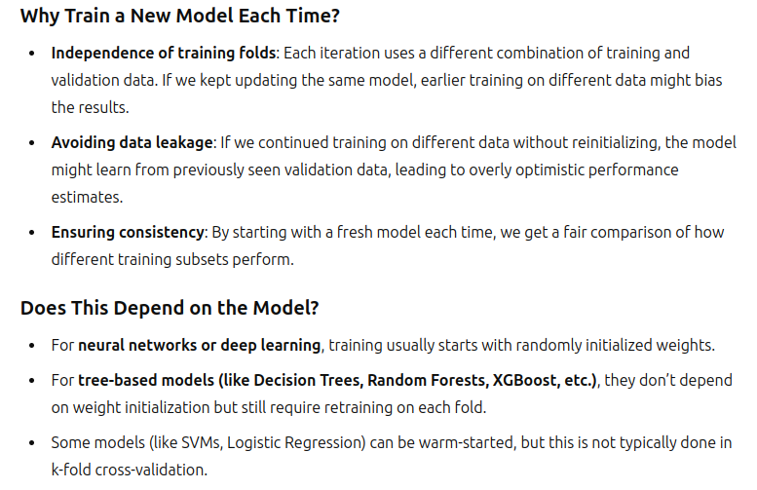
- 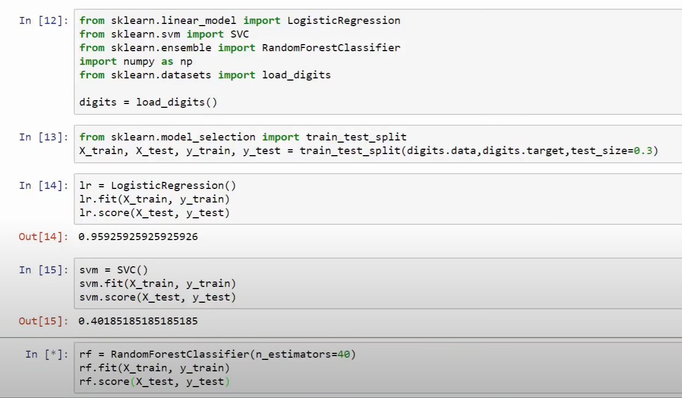
- 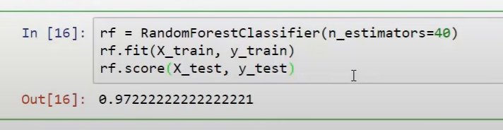
- Once again we run on the same dataset
- 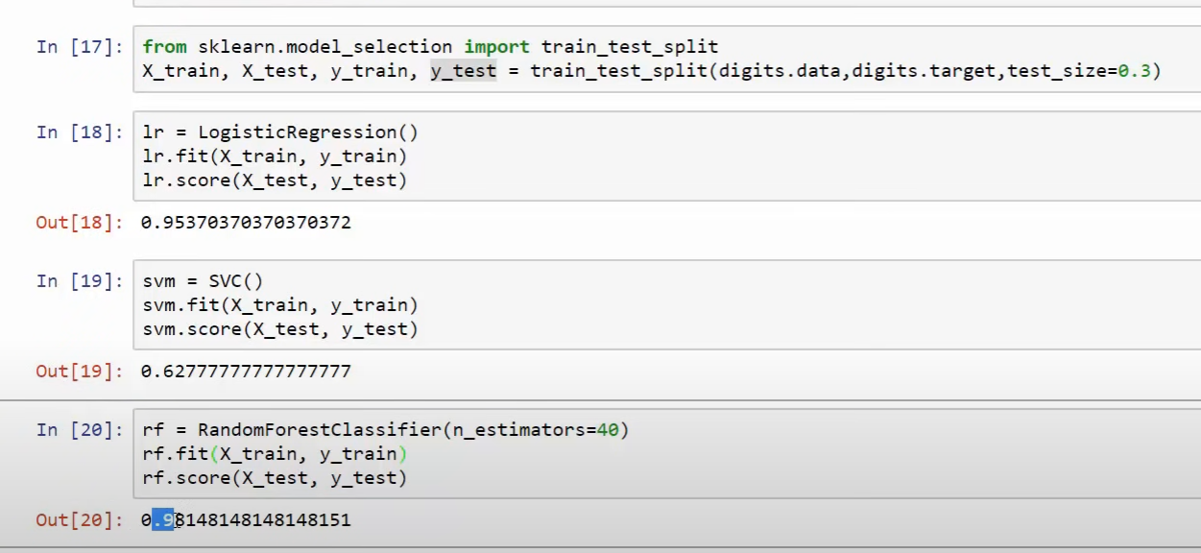
- Problem with train test split: Why the scores changed is because when we load the train test data from dataset. We loaded the different dataset. everytime we load, the data is different.
- 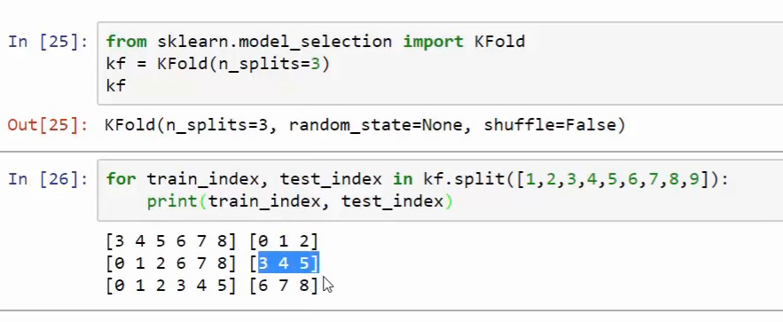
- 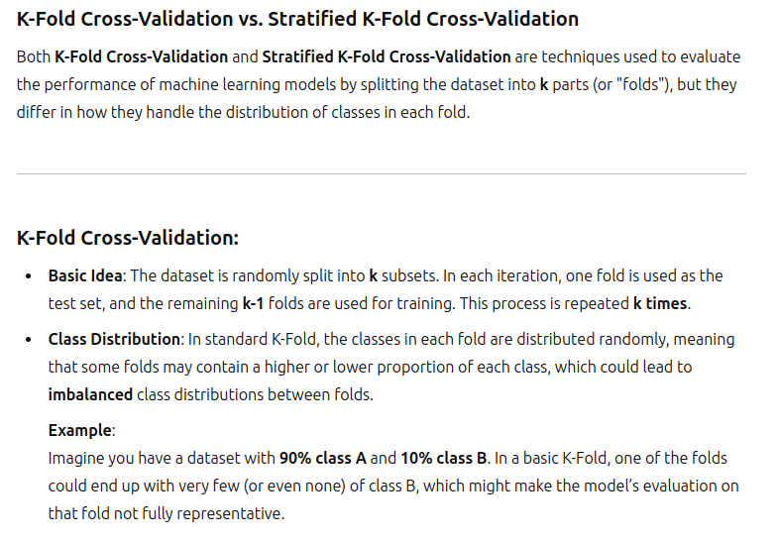
- 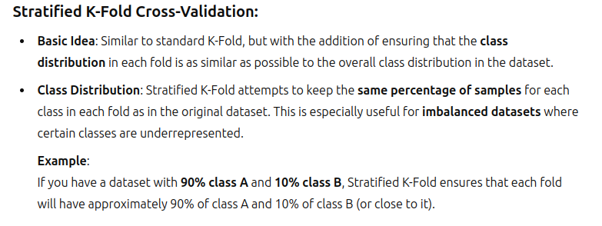
- 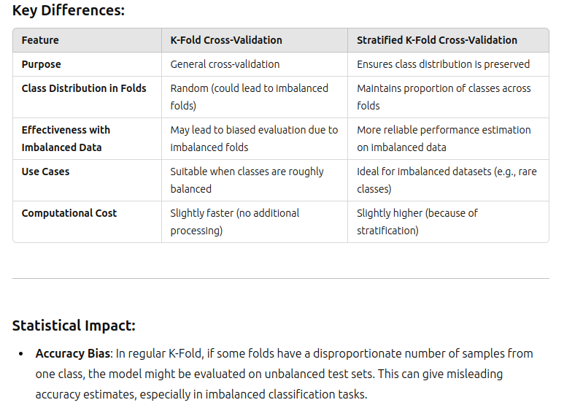
- 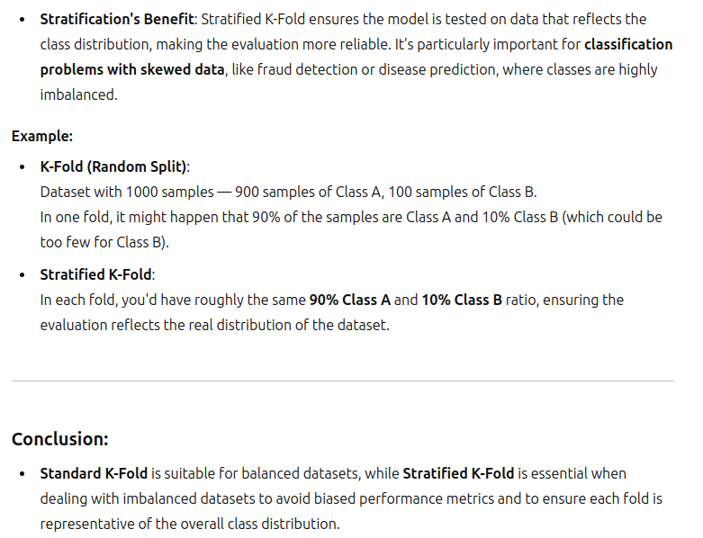
- 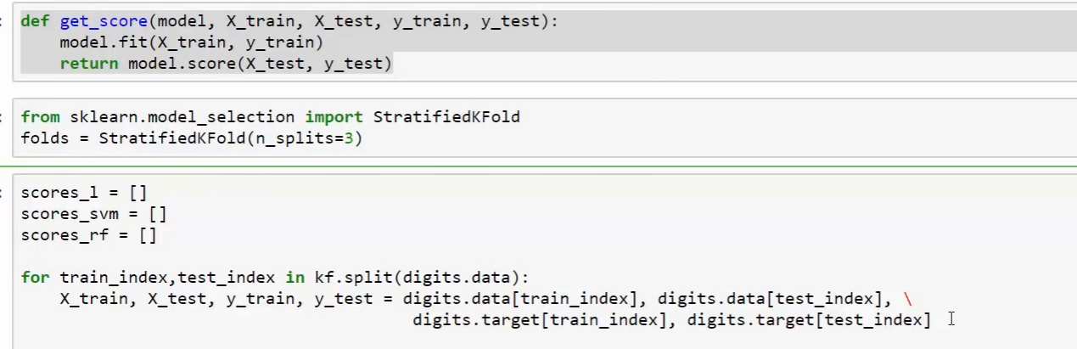
- 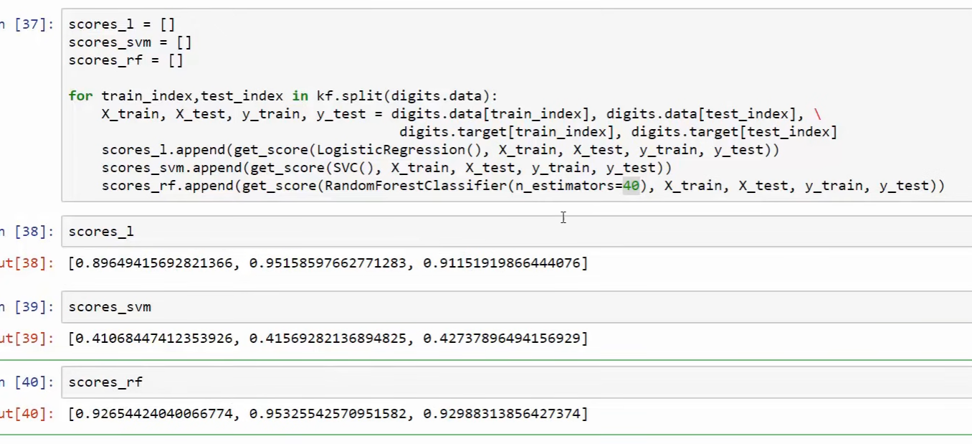
- 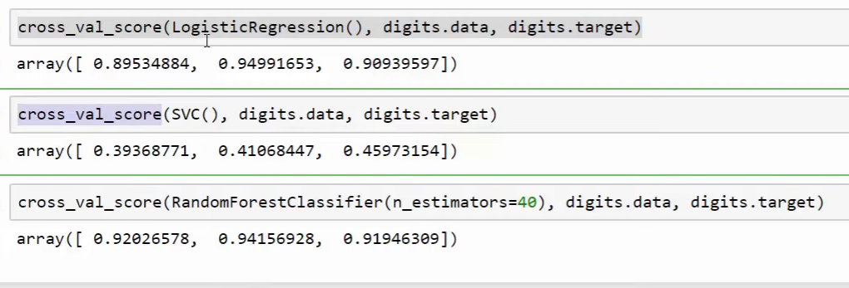
- 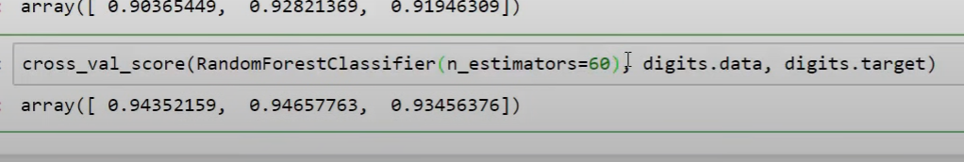
- 50 was better, especially in this.

Hyper parameter Tuning
- 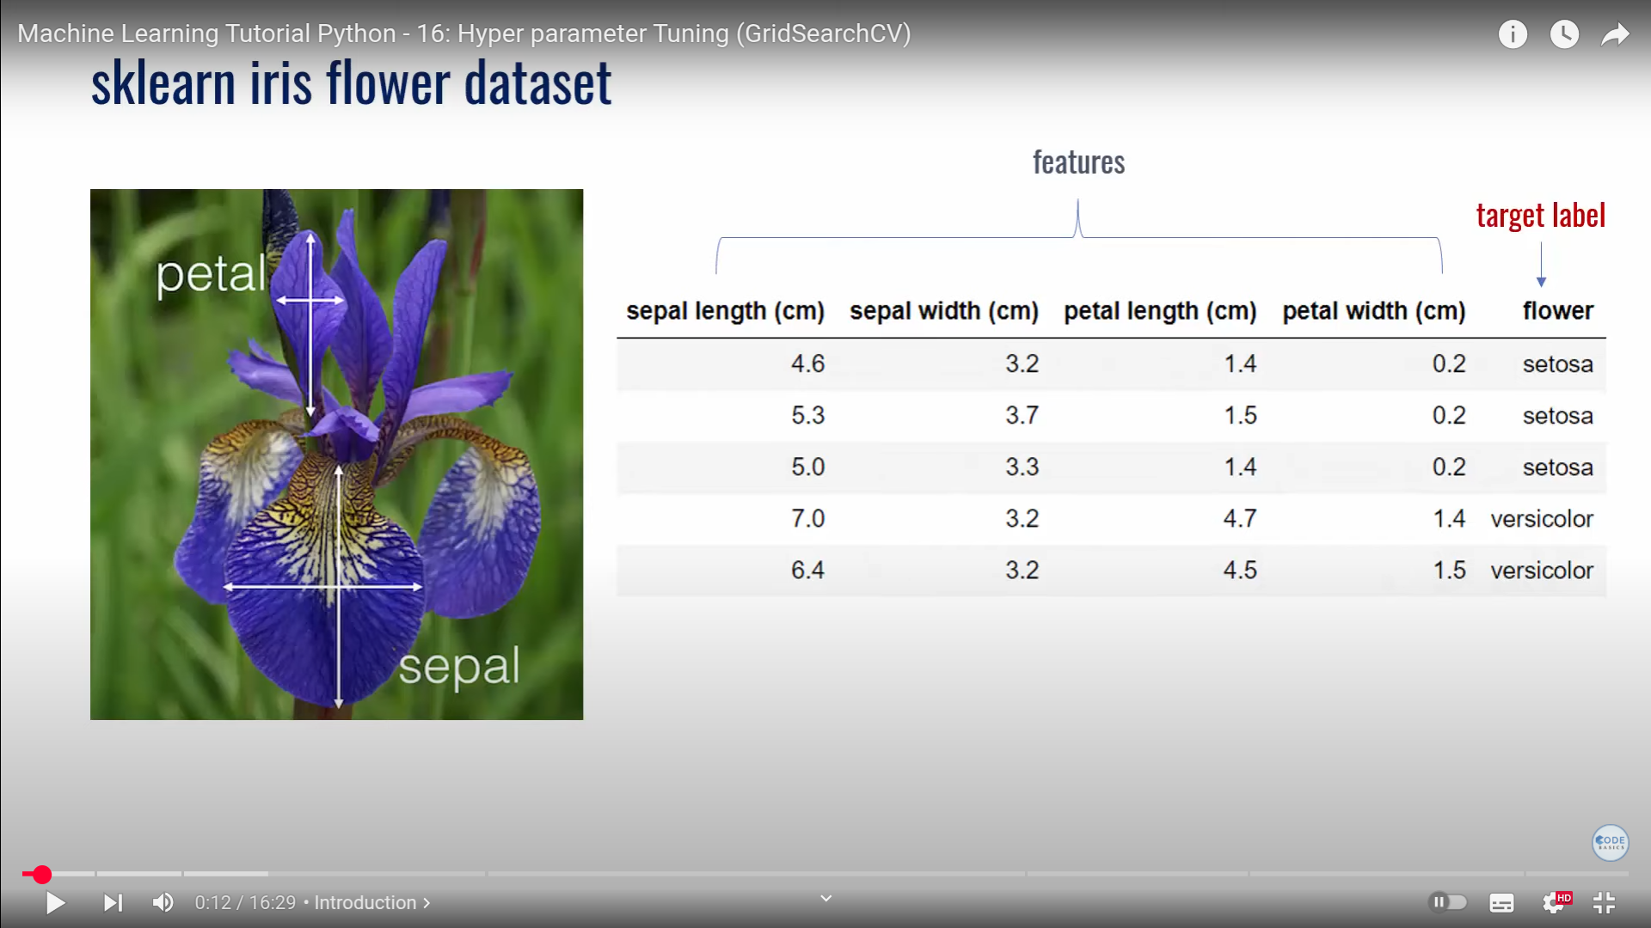
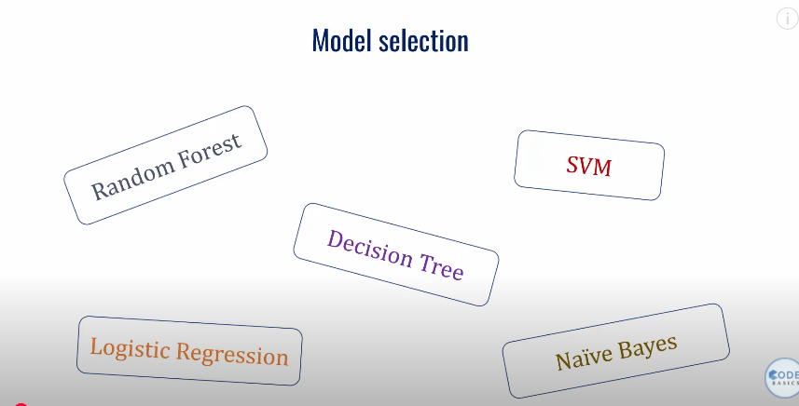
I have dataset, which model shall be used to make the prediction??
That too after choosing the model, what are the best for the model to choose to make the model gives the best accuracy.

Hyperparameter tuning: The process of using the best parameters, to the model is called the hyper parameter tuning.

- 